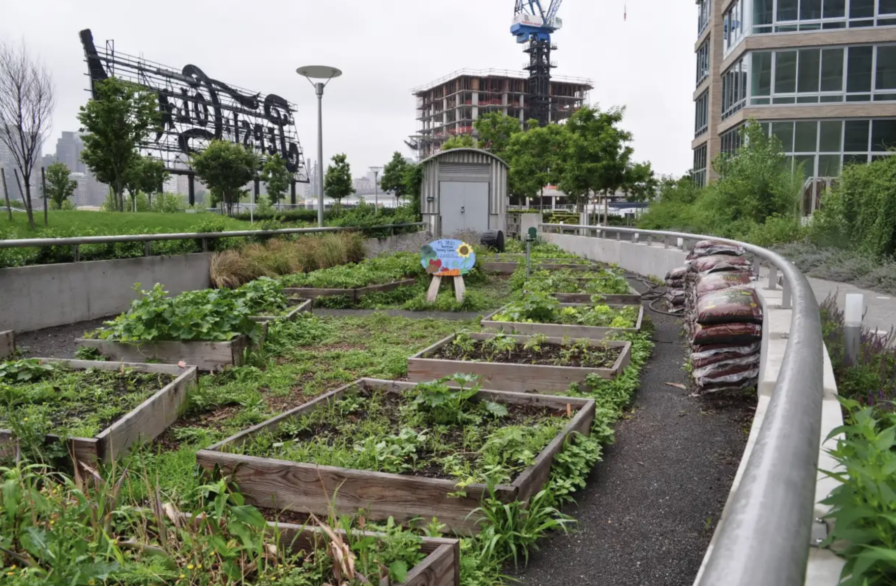

Rooftop gardens offer the ability to grow fruit and vegetables in dense city spaces while reducing temperature, energy use and storm water run-off

Food
Food is our most basic need and essential for survival. We all need a variety of food to take care of our nutritional and health needs. Food provides us with the raw materials from which to construct our bodies as well as the energy necessary to keep them fuelled up.
We derive our energy from the food we eat. Until the last century, all the food energy available came from the sun. Either you ate plants, or you ate animals that fed on plants, but the energy in food came ultimately from the sun. To increase yields, greater land needed to be cultivated. We have seen the global population increase with every increase in agricultural output. Human beings have appropriated almost all the prime land on the planet, about 40% of its area, and have forced all other species to use the remainder.
In the last 150 years or so, we have moved from an essentially agrarian rural existence to an urban industrial one. The concentration of people in towns is only possible because of industrialised agriculture. Cheap oil has enabled us to urbanise and globalise the production of food. Food is mostly sourced from the cheapest producers worldwide. It comes with a high environmental price and is unsustainable because of its dependence on oil, a finite resource.
The industrial food supply system is one of the biggest consumers of fossil fuels and one of the greatest producers of greenhouse gases. Ironically, these greenhouse gases, through the disruption of the predictable climatic cycles on which agriculture depends, have placed the food industry at serious risk from global warming.
Environmental degradation, water shortages, salination, soil erosion, and desertification all pose serious threats to our food supply and are made worse by climate change.

This series of city related policy and information briefs draws on lessons learned from cities and infrastructure work carried out by Triple Line over the past five years. It is intended to contribute to more sustainable, inclusive and climate-resilient cities that generate equitable economic growth opportunities for all by identifying market- driven solutions to urbanisation challenges and strengthening democracy and decentralisation processes through capacity building of government agencies at national, regional and city levels.
TRIPLE LINE POLICY BRIEF | CITIESWORK SERIES | TRIPLELINE.COM 01

Urban Agriculture
The key to building local resilience around food is timely planning. The threats to our food system require a comprehensive re-evaluation of the way we produce food. Firstly, we need to reduce the amount of meat we eat. This will free up agricultural land from crops produced for animal feed.
Secondly, we need to begin a widespread programme of urban agriculture ensuring that urban people are able to meet some if not all of their food needs by growing their own (see the example of Havana, Cuba overleaf). We also need to support local farmers and food producers to break the monopolistic system of few very large companies that control food supplies and land.
Reducing food waste and role of behavioural change and greater sharing of surplus is critical - if food waste were a country, it would have the third-biggest carbon footprint after the USA and China.
Thirdly, we need to reduce our dependence on oil in agriculture and find more energy efficient methods with fewer sprays and fertilizers. This means a new way of farming. There are different methods that produce high yields that are organic and regenerate the soil. Permaculture is one example and was successfully used in Havana. Permaculture is an approach to land management that adopts arrangements observed in flourishing natural ecosystems. It includes a set of principles derived using whole systems thinking.
Fourthly, we need to re-evaluate the policies we have adopted in relation to Genetically Modified Organisms (GMOs). The GMO route offers us uncertain and unintended outcomes as well as dependence on companies whose strategies are at best questionable.
Fifthly, we need to provide school children with the education and skills to grow food, by re-capturing subsistence skills that are rapidly being lost.
The issues around food are too serious to be ignored.

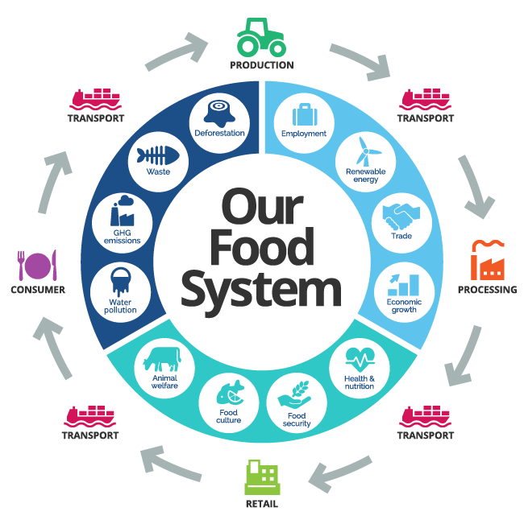
Basic components and processes involved in the current food system from production and processing to distribution, consumption and disposal.

Source: 3Keel

TRIPLE LINE POLICY BRIEF | CITIESWORK SERIES | TRIPLELINE.COM 02

Fighting oil dependence with urban agriculture in Havana
Twenty-five years ago, Cuba was on the brink of famine. But a homegrown farming revolution has rebuilt the country’s food supply from the bottom up: organic, affordable, and resilient. Cuba’s capital city, Havana, is cited as a world-leading example of good practice in urban food production, producing up to 100% of its fresh vegetables. Urban farming saved the city when the collapse of the Soviet Union led to a sudden oil shortage and monetary shortfalls. This led to food shortages and undernourishment. Cubans had to adapt, adopting non-oil-dependent agriculture and other measures. These included creative use of space for urban farming, farmers markets, policies on biodiversity. The impact has been massive with thousands of urban farms and community gardens created. Havana has some 30% of available land under cultivation. Benefits have included:
- Higher resilience of food supply chains.
- Better public health via improved nutrition due to greater access to less expensive fresh vegetables.
- Urban agriculture has preserved rarer plant species once part of the traditional Cuban diet.
- Reduced energy use.
- Employment creation.
- Reduction of fossil-fuel use.

What should cities do?

- Introduce a well-resourced urban agriculture programme with incentives for small scale producers
- Open local fresh produce markets for locally produced fruit and vegetables
- Adopt chemical free agricultural practices such as permaculture
- Establish an urban agriculture educational programme for anyone interested in producing food locally
- Conduct an audit of unutilised urban land that could be used for urban agriculture
- Monitor the health benefits of eating more fresh produce
- Consider adopting a ‘Food systems approach’ aligning actions across policy areas and between different levels of governance
- Strengthening urban-rural linkages and integrated territorial planning

PLEASE CONTACT:
Mathis Primdal: mathis.primdal@tripleline.com
Richard Slater: richard.slater@tripleline.com

TRIPLE LINE POLICY BRIEF | CITIESWORK SERIES | TRIPLELINE.COM 03

